Header
Top Bar – Left side 70% scrolling text (put dummy for now) | Right Side 30% phone number, whatsapp & email
Main Header
- Logo - left
- Menu (center) – Gaming PCs, Build Your PC, Components, Peripherals, Business Solutions
- Search, Wishlist, Account Cart – Right

Hero Section
Title - Build Your Dream Gaming PC
Sub-Title/Content - High-performance custom gaming PCs built by experts using genuine components. Whether you're gaming, streaming, editing or creating—we build exactly what you need.
CTA - Explore Gaming PCs | Build Your Own PC
- 3 Experience Stores
- Expert Cable Management
- Lifetime Technical Support
- Genuine Components
- Pan India Shipping
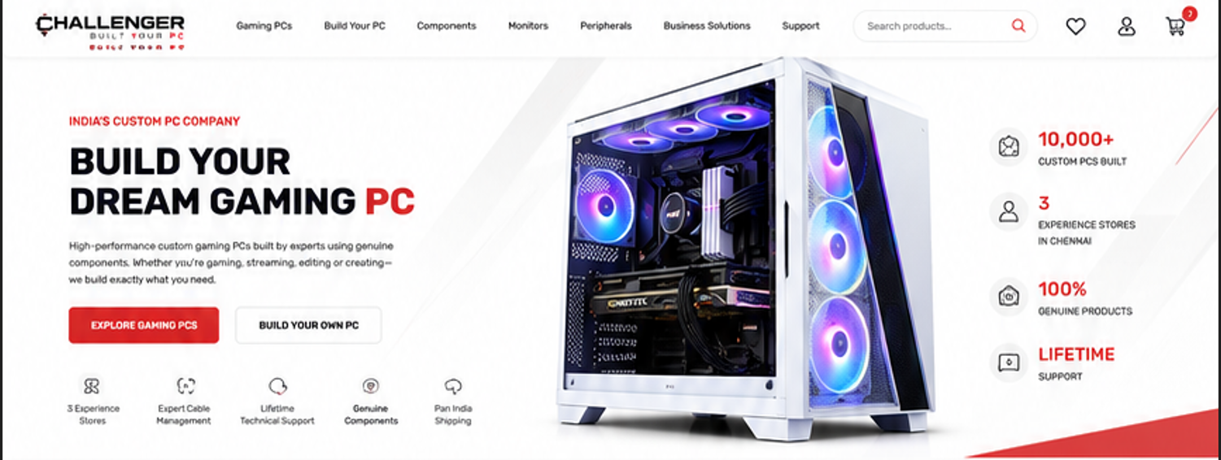
Choose Your Journey Section
Title – Choose Your Journey
5-6 Cards with Image and Title inside it
- Gaming PCs | RTX Gaming Builds
- Editing Workstation – show 4-5 editing tools
- AI Workstation – show Machin learning & Artificial Intelligence
- Streaming PC – show multi monitor setup
- Office/Business Purpose PC – Home, Work, Student
- Build Your Own – Custom PC Configurator
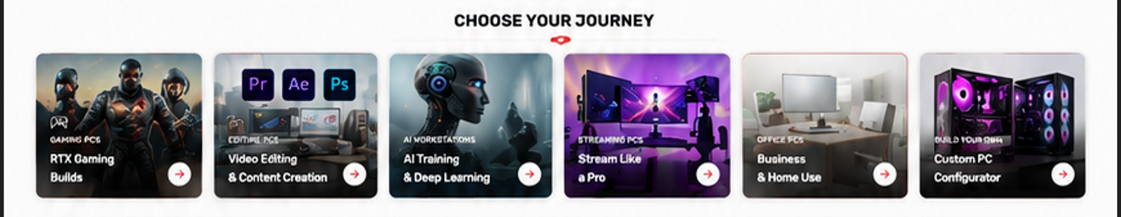

Section-3
Title – Find Your Perfect PC
Content - Choose your PC based on your budget, performance or purpose.
Show 3-4 Tabs (Gaming PCs, Editing PCs, Office/Work PCs)
Show 5 PCs in each tag like the screenshot below
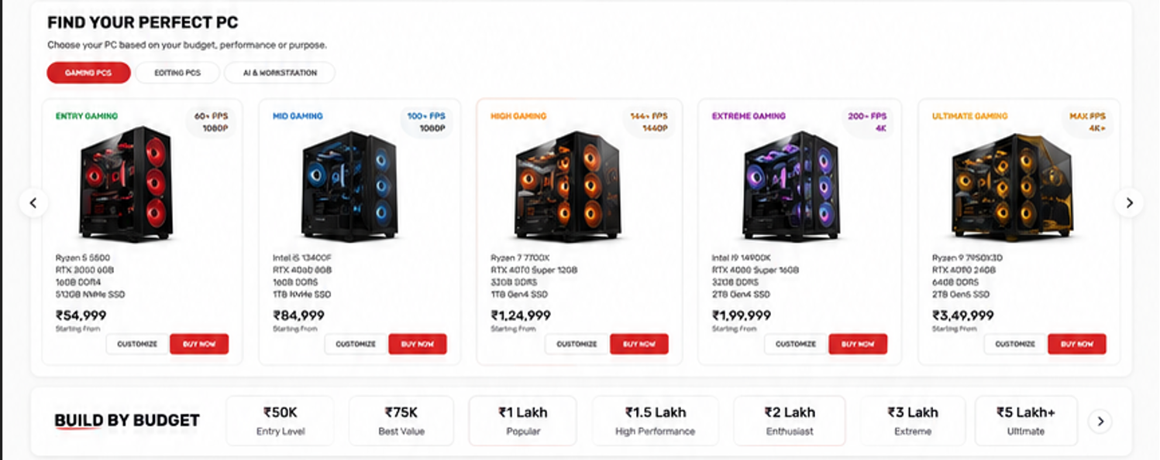
Section-4 (reference in above screenshot only)
Title - Build by Budget
Show 5-6 budgets ranging from 50k to 5 lakhs in parts of 1-2 lakhs

Section-5
Title – Top Selling
Show – 10 random products (5 columns x 2 rows)
Reference link: https://woodmart.xtemos.com/mega-electronics/
